RESOLUTION NO.__________

RE: CERTIFICATE OF APPROPRIATENESS UNDER THE
PROVISIONS OF THE ACT OF THE PENNSYLVANIA
LEGISLATURE 1961, JUNE 13, P.L. 282 (53
SECTION 8004) AND BETHLEHEM ORDINANCE NO.
3952 AS AMENDED.

WHEREAS, it is proposed to install a roof over the rear door at 265 E. Market St.

NOW, THEREFORE, BE IT RESOLVED by the Council of the City of Bethlehem that a Certificate of Appropriateness is hereby granted for the proposal.

Sponsored by: (s)

(s)

ADOPTED BY COUNCIL THIS DAY OF

(s)
President of Council

ATTEST:

(s)
City Clerk

HISTORICAL & ARCHITECTURAL REVIEW BOARD

The applicant is proposing to install a roof over the rear door at 265 E. Market St.
APPLICATION #1:

Jay Brew
265 E. Market St.
Bethlehem, PA 18018

OWNER:

__________________________________________________________________________

The Board upon motion by Marsha Fritz and seconded by Derrick Clark adopted the proposal that City Council issue a Certificate of Appropriateness for the following:

- New roof to be cedar (painted) and the slope of the new roof should match the pitch of the main house roof.

2. The roof will be approx.. 48” wide, 30” high and project approx.. 20”.

3. Rafters will be 2” x 6” cedar detailed with a chamfer similar to the house
overhangs.

4. The shingle pattern will be a “scalloped” configuration.

5. Flashing will be copper with a painted aluminum drip edge in a matching color.

6. The motion was unanimously approved.

__________________________________________________________________________

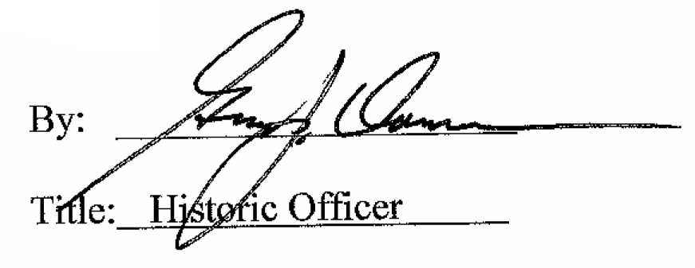

Date of Meeting: July 5, 2017

